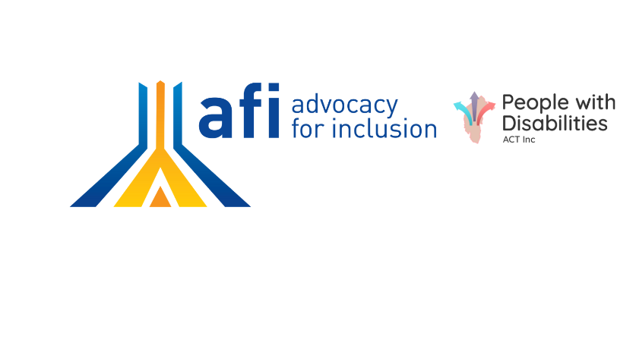

**What’s happening**

* The Federal Government is trying to remove many supports that people with disability use in the NDIS and is consulting about this
* These include: household appliances, menstrual products, batteries, and recreation equipment as well as supports for sexual expression
* While there has been a short extension, this is a flawed consultation with very little time for you to engage
* We need many people to have their say

**Submission tips**

* Act now before it’s too late
* Send to [NDISConsultations@dss.gov.au](mailto:NDISConsultations@dss.gov.au) by 5pm Sunday 25h August 2024
* Make it your own
* Add your story
* Read the list of supports being removed here: <https://engage.dss.gov.au/consultation-on-draft-lists-of-ndis-supports/draft-list-of-ndis-support/>

**Some ideas for a letter**

Email: [NDISConsultations@dss.gov.au](mailto:NDISConsultations@dss.gov.au)

Dear Department of Social Services,

I am writing to express my deep concerns about the proposed lists of included and excluded NDIS supports. These lists are rushed, flawed and will have massive unintended negative consequences for people with disability if implemented. A rules based approach to supports is not in line with choice and control nor was it the first step recommended by the NDIS Review. Key issues with the proposed lists include:

1. They reflect an outdated model of disability supports that is othering and medicalised. The lists would force people to use expensive specialist providers for items that could be purchased more cheaply and effectively from mainstream sources.

2. Excluding everyday items like household appliances, batteries, and recreation equipment will make it harder for people with disability to live independently in the community. These items are often crucial disability supports when used creatively. Excluding other items, like menstrual products ignores the real need and additional costs faced by people with disability as well as the complexity of disability. Removing these options also reduces amenity and dignity especially for personal items.

3. The lists are overly restrictive and will stifle innovation in how people use their NDIS funding to meet their needs.

4. Flexibility and choice are core principles of the NDIS. These changes remove choice from individuals and hand control over support selection to Governments who do not understand our needs.

5. Even with a one week extension, there has not been enough time or genuine consultation with the disability community on these major changes including very little time with plain English materials for people with intellectual and cognitive disability.

6. Real co-design is needed in conjunction with the disability community before developing any Rules, as well as considering passing legislation.

7. The proposed approach contradicts recommendations from the recent NDIS Review for more flexible budgets with minimal restrictions.

8. Forcing people to use more expensive specialist disability products and services will likely increase costs for the NDIS overall.

9. The consultation period and arrangements are completely inadequate given how big these changes are and how many supports are being removed. We need more time to properly review and respond to these proposals.

10. Removing and restricting support items like these risks forcing people to rely on state and territory systems that either don't exist or won't be ready in time. This could leave many people without the supports they need.

Some of the supports I’m particularly concerned about include: *<suggestions: strike out non applicable and personalise>*

* Access to menstrual products because they enable me to live with dignity with a complex disability (add own reasons if you feel comfortable)
* My smart household product which has features which enable me to operate it but is not a specialised product
* Visiting a hairdresser to wash my hair as this prevents the need for more support workers and saves my dignity
* Use of my smartwatch which reduces worker costs, health costs and gives me greater independence
* Trampolines or games because these are great for therapy and exercise for me
* Gaming therapy or yoga as this is an effective evidence based form of physical therapy for me.

I urge you to abandon these flawed lists and instead work closely with people with disability to develop a more flexible, person-centred approach to defining reasonable and necessary supports, before making any further changes to the NDIS.

Any future guidance should empower participants to make choices that work for them, not restrict their options. There is still time to get this right, but it requires slowing down and truly listening to the disability community. Please do not rush through these damaging changes.

Regards

<Your name>

<Date>